Early Childhood Data System

- Prekindergarten Data Submission 2022 – 2023
- Timelines
- TWEDS
- Core Collection Roles
- Converter & Validation Tool
- ECDS Data Upload
- Load Assessment Data
- Promote ECDS Data
- Validate ECDS Data
- Prepare/Finalize Process

Reporting ECDS Pre-Kindergarten Data to TEA

The reporting of prekindergarten program data for ECDS is mandatory for all public-school districts and open-enrollment charter schools. The district will provide district/campus data, student data, staff data, and master schedule data. The assessment vendors will provide the assessment data and student scores. Districts that did not administer an assessment from the commissioner approved list must still submit PK student demographics, course section data, and staff data. Data submission is mandatory on 4-year PK students. If a district offers stand-alone PK3 classes specific progress monitoring is not required. If students are served in a mixed classroom (PK3 with eligible PK4) where progress monitoring is required, the teacher should implement progress monitoring that is developmentally appropriate for students and may adjust monitoring for the 3-year-olds or exclude 3 year olds if it is deemed developmentally inappropriate.

ECDS Assessment Timeline

Grade | BOY | MOY | EOY
Pre-Kindergarten | September - November | January – February | April - June
Kindergarten | September – October | January – February | April - May

ECDS Submission Timeline

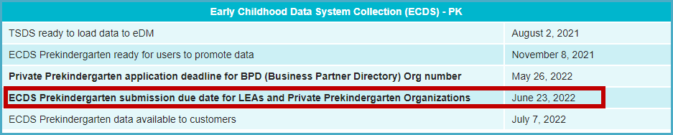

ECDS Prekindergarten Commissioner Approved Assessments

https://www.texasstudentdatasystem.org/sites/texasstudentdatasystem.org/files/2022-2023-ecds-assessment-specifications.pdf

https://tealprod.tea.state.tx.us/TWEDS/98/492/823/0/CodeTable/List/14669

TSDS Web-Enabled Data Standards (TWEDS) 2022-2023

http://www.texasstudentdatasystem.org/TSDS/TEDS/TEDS_Latest_Release/

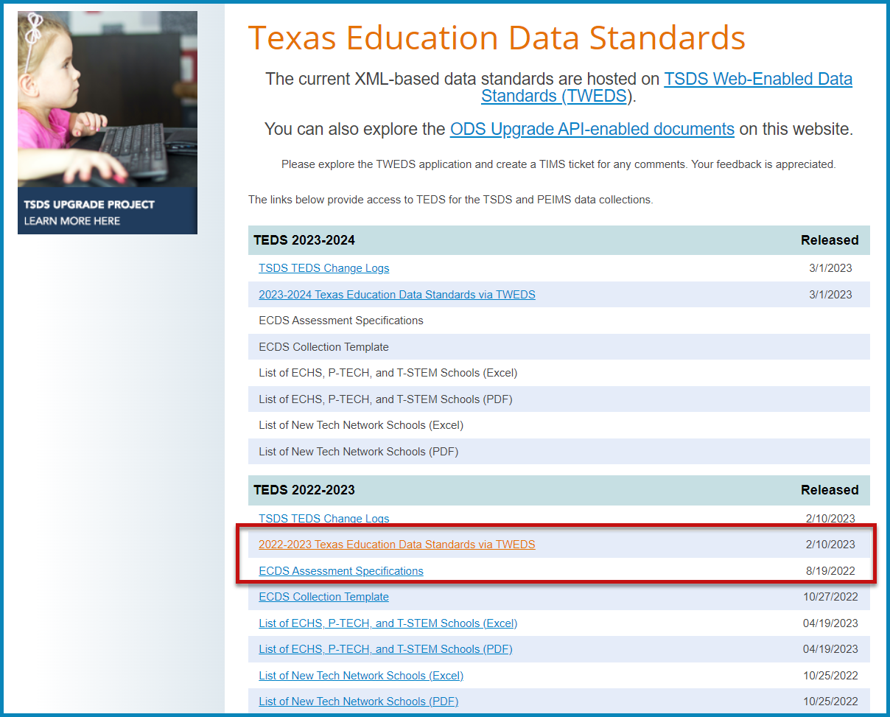

Note: The ECDS Collection Template located here is for reporting by Private Prekindergarten Programs only.

PK High Quality Data Elements

Home Room Indicator

The Home Room Indicator will be used to designate the PK teacher who administered the Commissioner approved assessment.

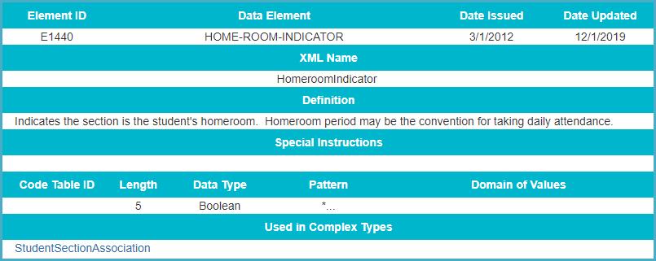

PK Curricula

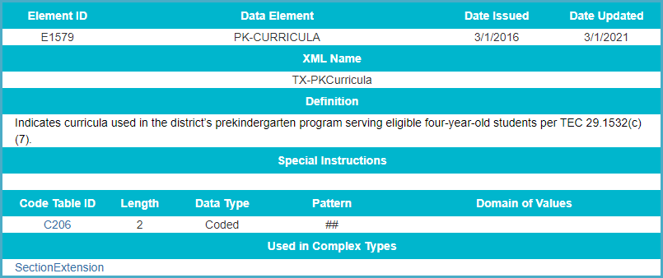

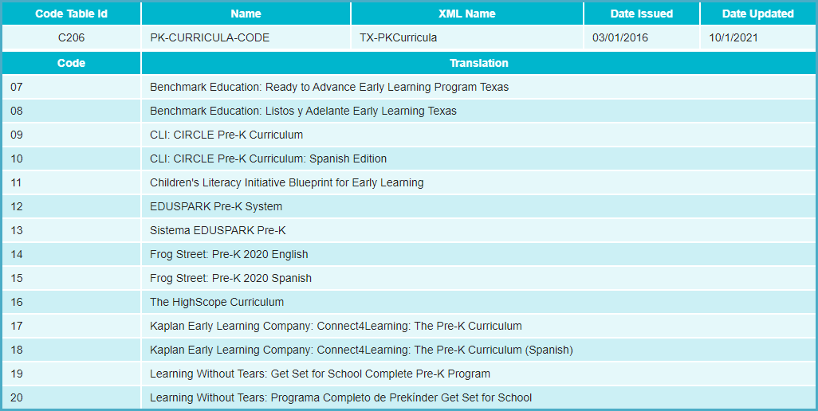
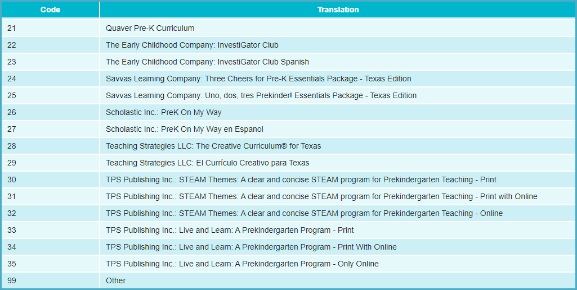

PK School Type

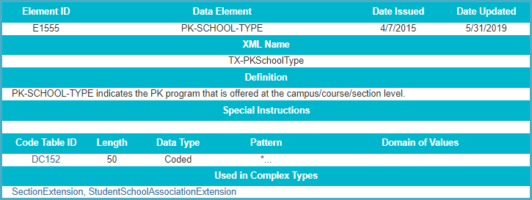

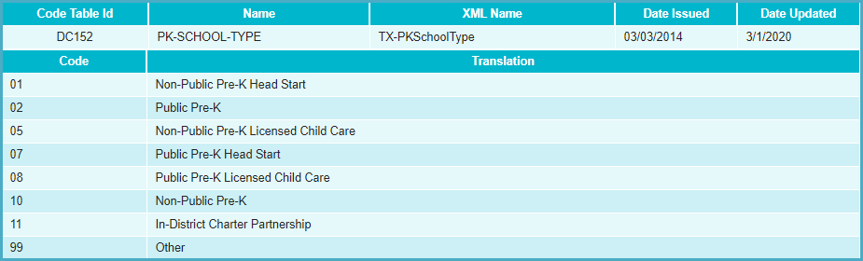

High Quality PK Program Indicator

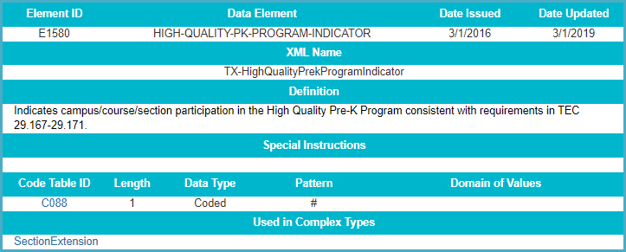

Class Position Type (PK Classroom Aide)

PK Classroom Aide indicates the Classroom Aide (Role ID 033) serves the Teacher of Record on a regular or irregular basis in the Pre-Kindergarten classroom. This allows the district to meet the student-to-staff ratio to 11:1.

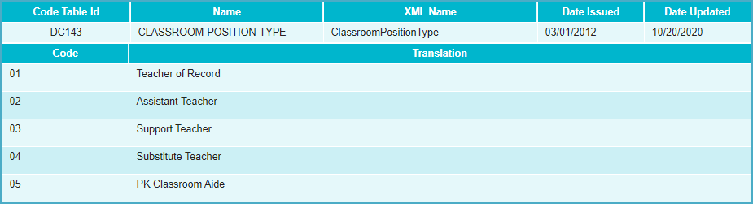

Family Engagement Plan Link

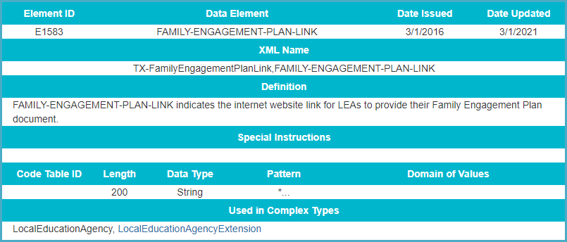

ASCENDER Example:

Maintenance > Master Schedule > Campus Schedule > Section Tab

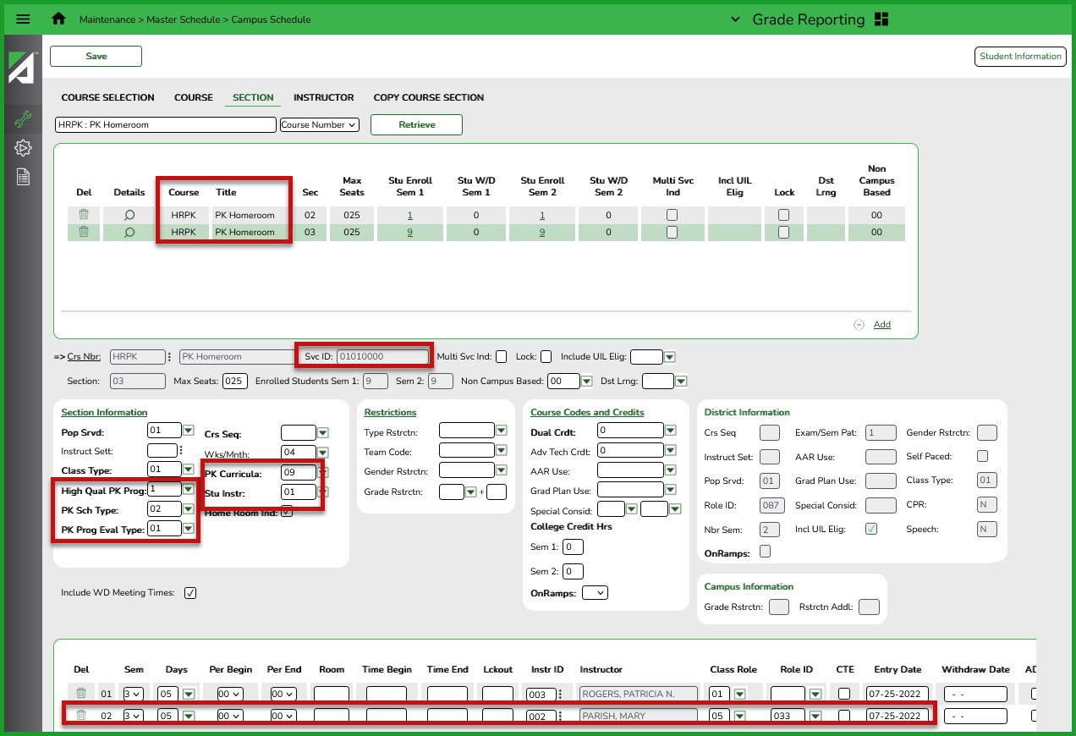

Skyward Example:

Course Master > Edit Section > Texas State Specific

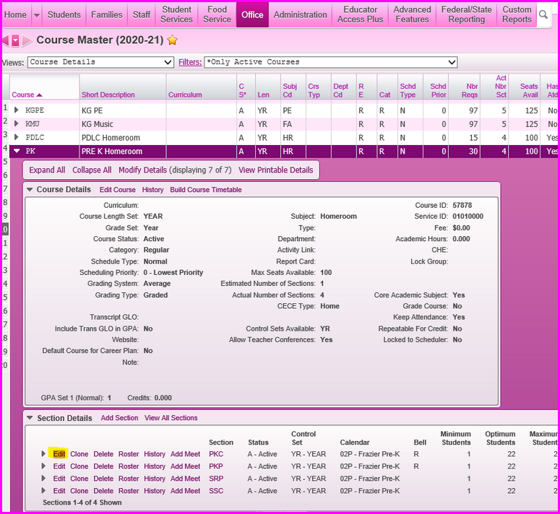

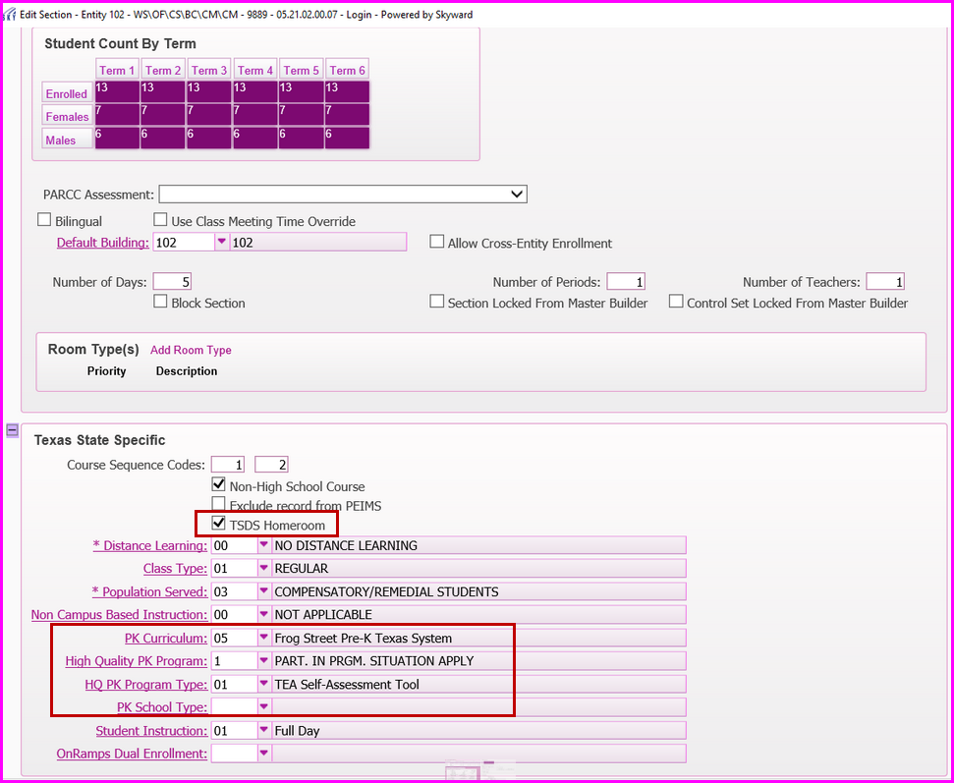

PK Teacher Requirement

Each teacher for a prekindergarten program class must be certified under Subchapter B, Chapter 21; and have one of the additional qualifications found in the C207 code table.

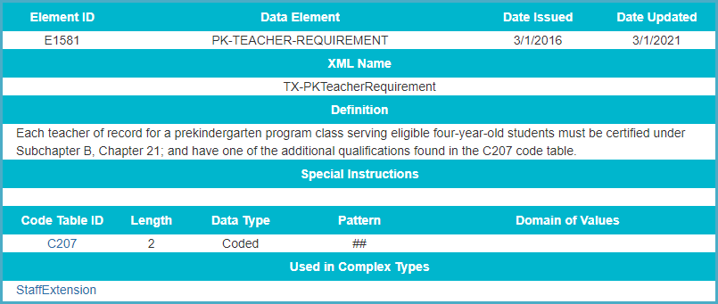

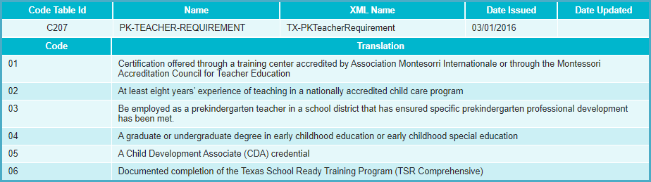

ASCENDER Example:

Human Resources > Tables > Credential > Teaching Specialization tab

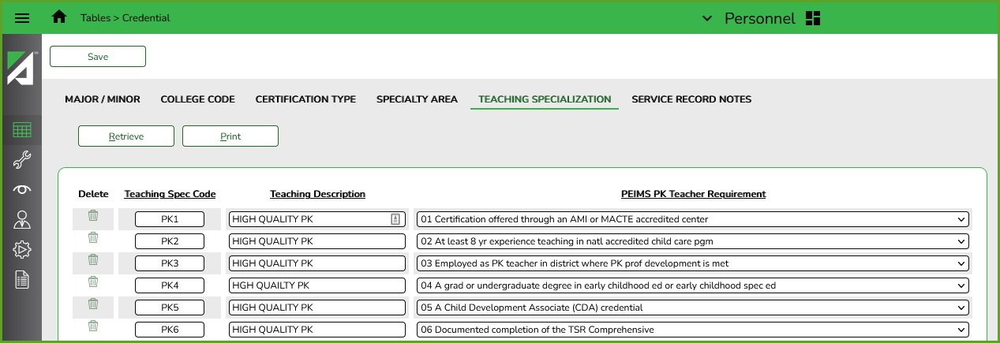

Human Resources > Maintenance > Staff Demo > Credentials tab

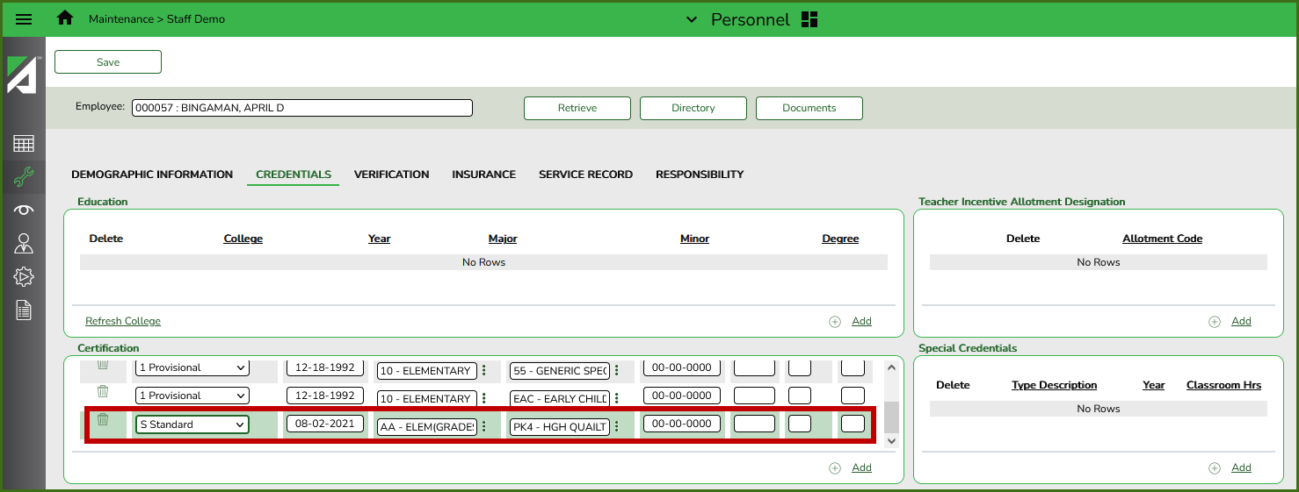

Skyward Example:

Staff Information - Entity 000 - WS/SF/SR – 11264 – 05.21.02.00.07

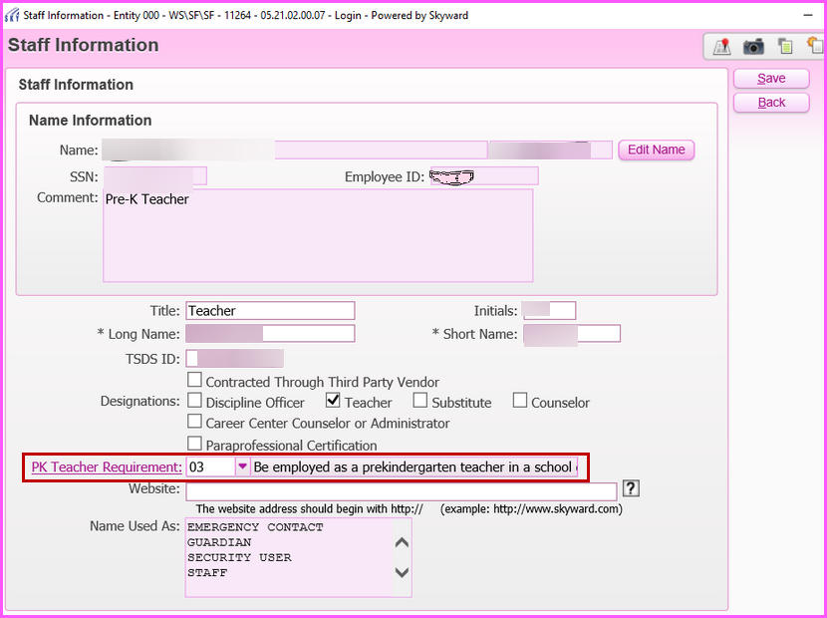

Core ECDS Roles

- ODS Data Loader – The person designated to load ECDS data into TSDS.
- Core Data Completer with ECDS Access Privilege – The person designated to promote, validate, and complete the ECDS Submission.
- Core Data Approver with ECDS Access Privilege – The person designated to request an extension for the ECDS Submission. Core Submissions do not require Superintendent Approval (SOA).

Validation Tool

Download the latest tool at TEAL > Texas Student Data System Portal > Utilities

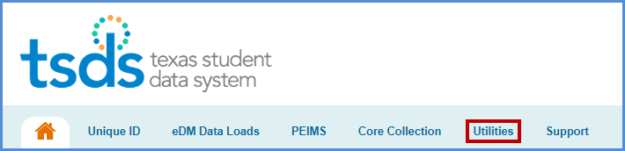

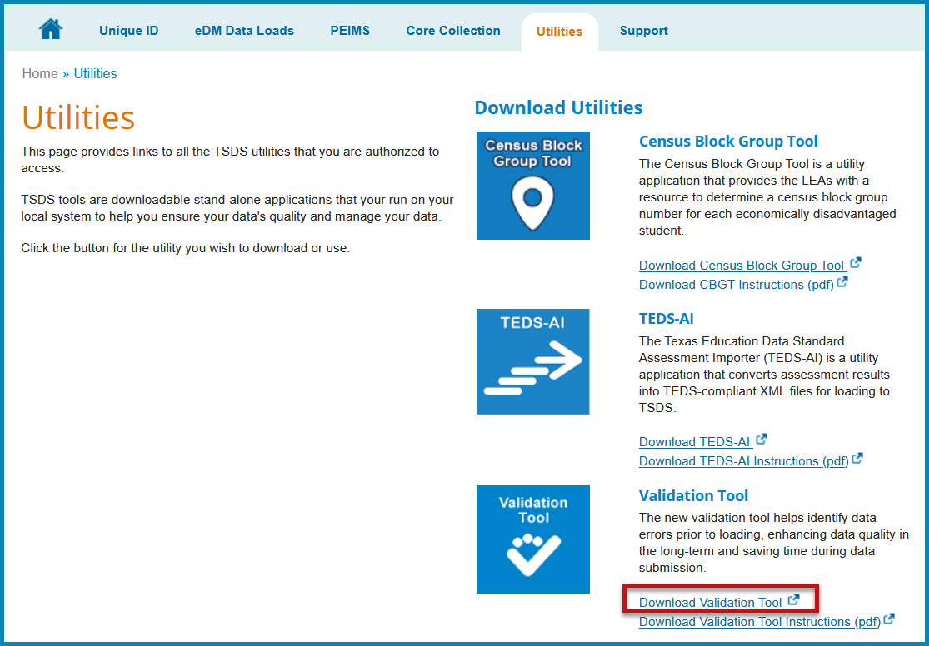
To Verify Version – Help Menu

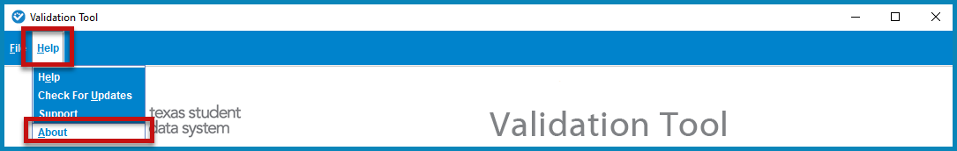

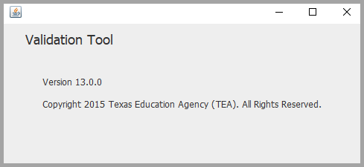
- Help – Directs the user to the TSDS Conversion and Validation Tool User Guide

- About – View the version number

ECDS PK Interchanges

ECDS PK interchange files from the district student software will be uploaded to 2023 TSDS.
ECDS PK assessment interchange files will need to be retrieved from the assessment vendor and uploaded in 2023 TSDS.

Prekindergarten

InterchangeEdOrganization
InterchangeMasterSchedule
InterchangeStudentParent
InterchangeStudentEnrollment
InterchangeStaffAssociation
InterchangeStudentProgram

InterchangeAssessmentMetaData *
InterchangeStudentAssessment *

*Assessment Interchanges must be downloaded from the Assessment Vendor and uploaded by the district.

Validating XML Data

- Select File > Validation Tool. The Validation Tool opens in a separate window.

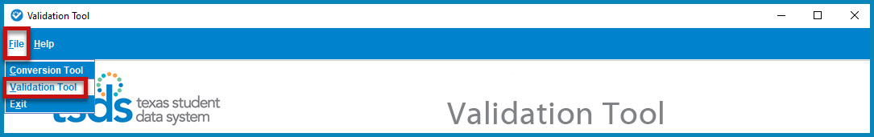

- Select the School Year 2022 - 2023.
- Select the Collection > TSDS.
- Click the folder icon to browse and select the ECDS files.

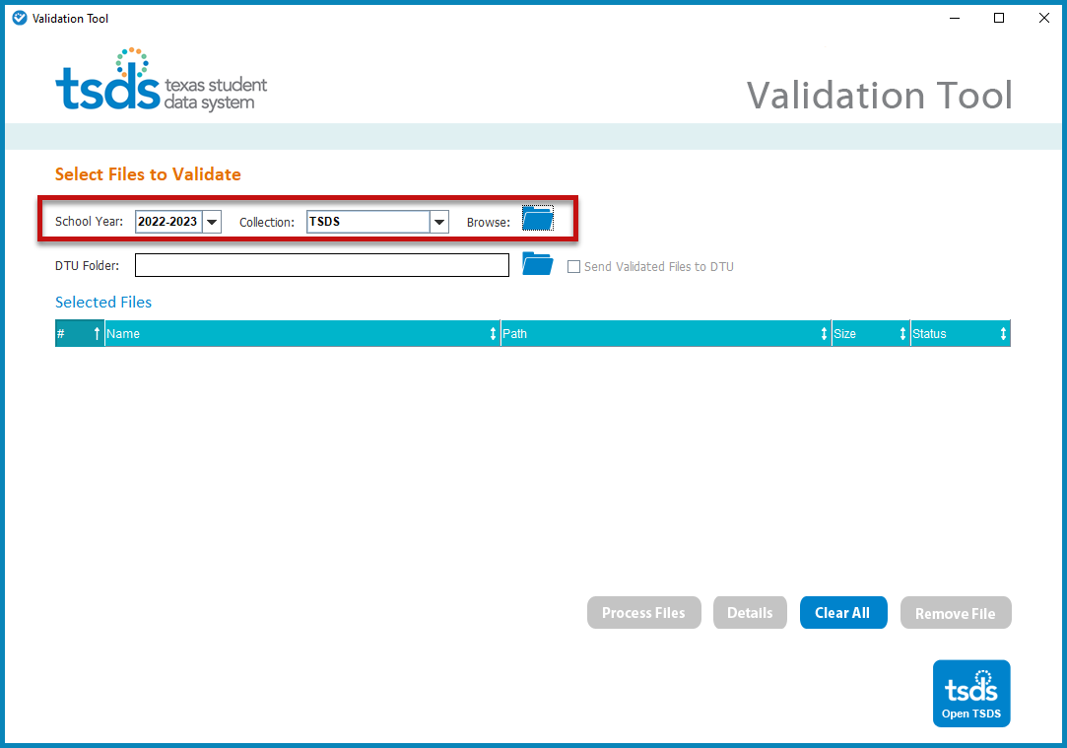

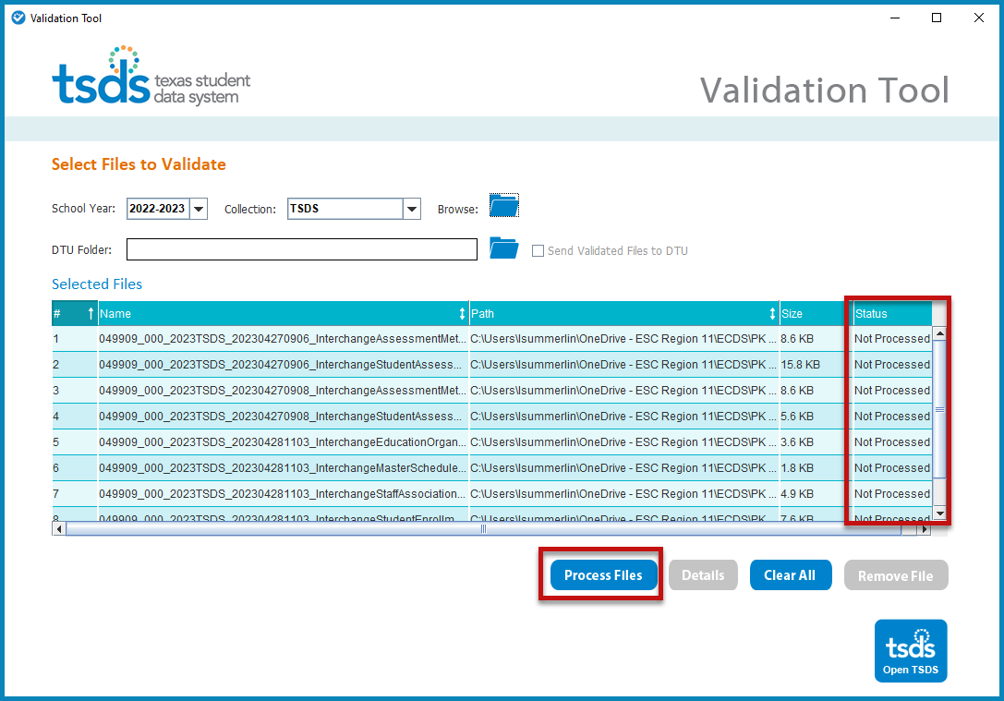
- Click Process Files. The results of the validation are reported in the status field.
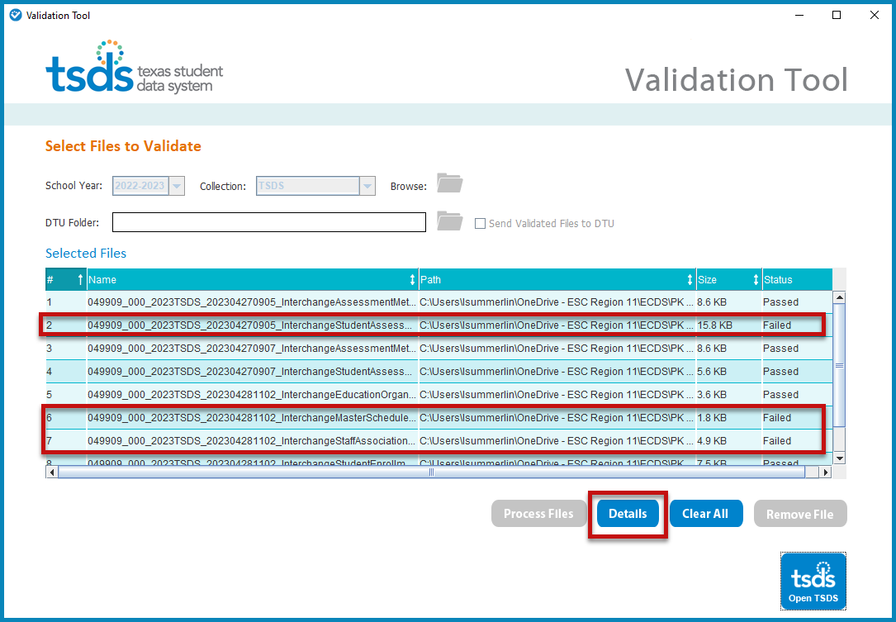

- If any files Fail, click on the file name, and click the Details button. From this page, errors can be printed by clicking Print All Errors or click Export All Errors to export them to a spreadsheet.

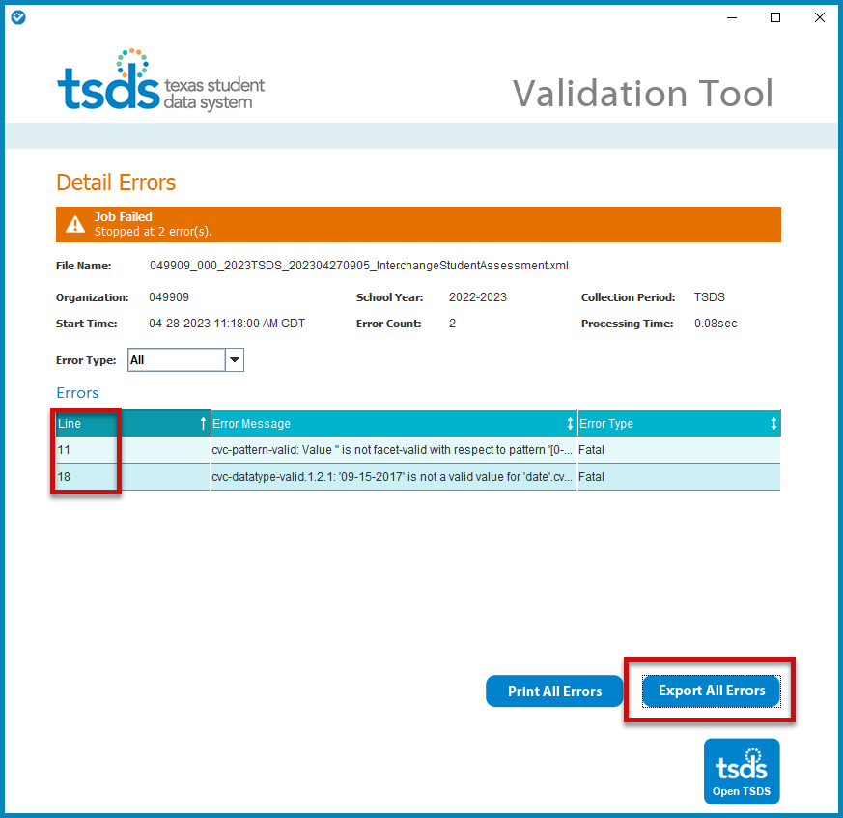

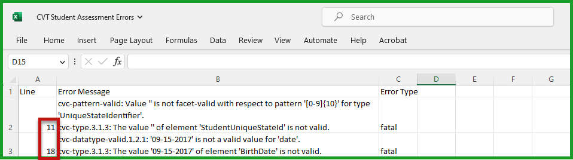

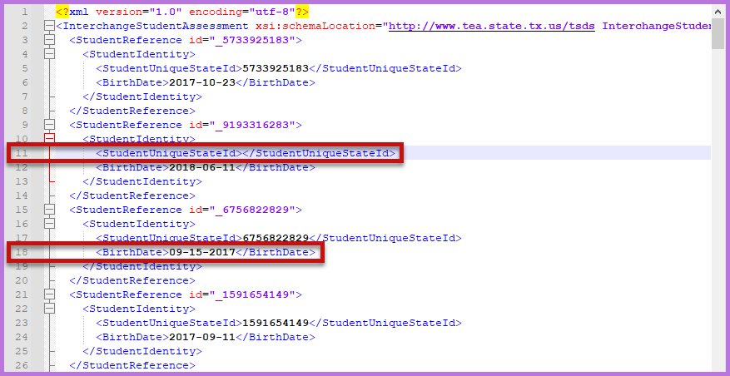
- Make corrections as needed. Create new interchanges and process using the Validation Tool. Once all files have passed, upload into TSDS.

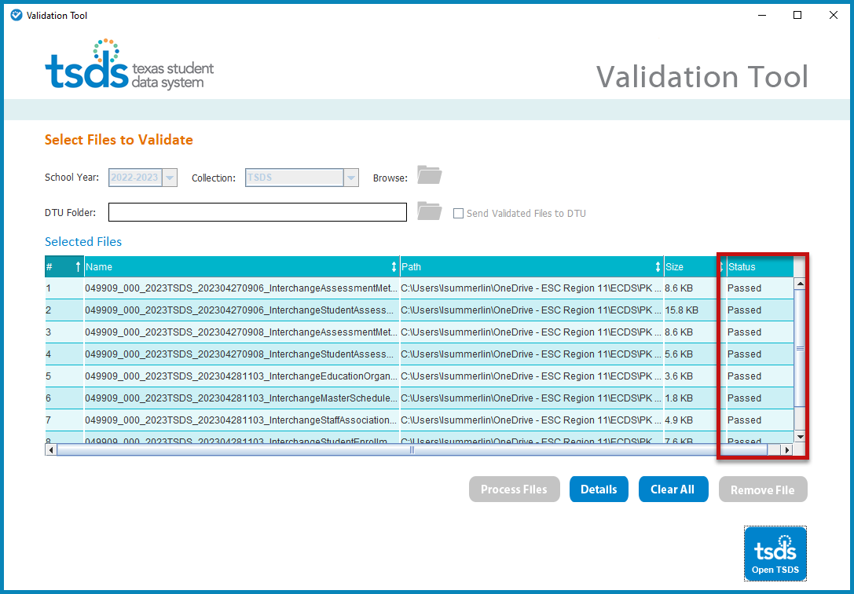

TSDS – ECDS Data Upload

The TSDS portal is how users access any of the TSDS applications or utilities. The tabs that appear on the portal depend upon the access the user has been granted in TEAL. The eDM Data Loads tool allows users to load data from their local systems to TSDS.

- Log in to TEAL and select Texas Student Data System Portal.
- On the Home screen select Manage Data Loads.

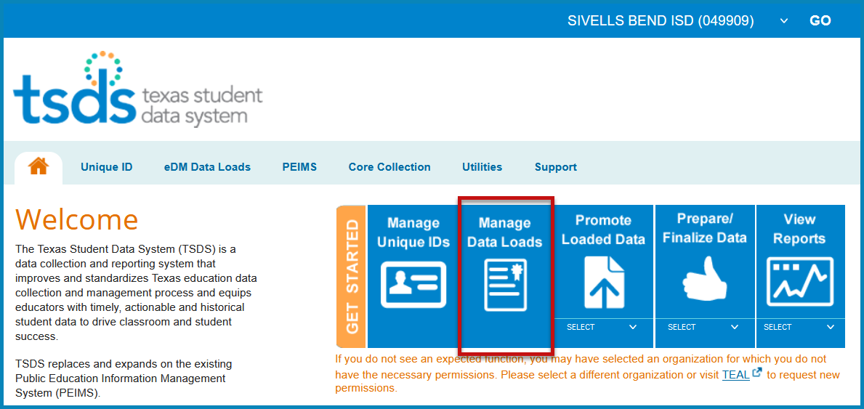

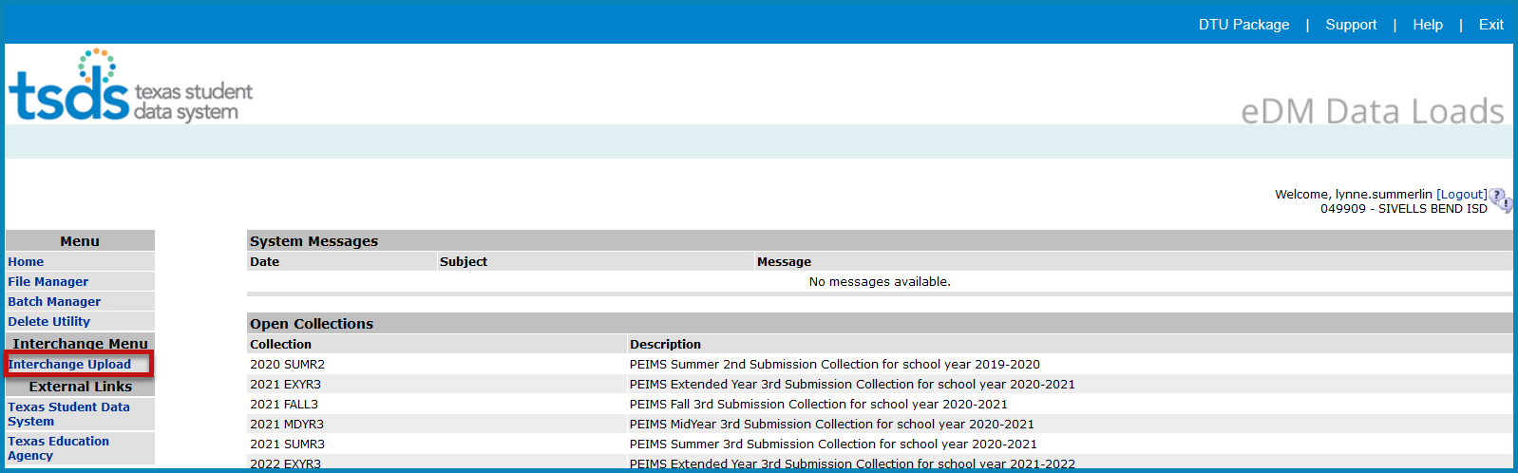

- Under Interchange Menu, select Interchange Upload.
- Select the Interchange Collection from the drop-down menu (2023 TSDS).
- Click the Browse button for File 1 and select the first file to be uploaded.
- Repeat Step 5 for any files needing to be uploaded. Files may be uploaded individually or as one zipped file.

Note: Files must be loaded in the following order if uploaded individually:

- InterchangeEducationOrganizationExtension
- InterchangeMasterScheduleExtension
- InterchangeStaffAssociationExtension
- InterchangeStudentParentExtension
- InterchangeStudentEnrollmentExtension
- InterchangeStudentProgramExtension
- InterchangeAssessmentMetadata
- InterchangeStudentAssessment

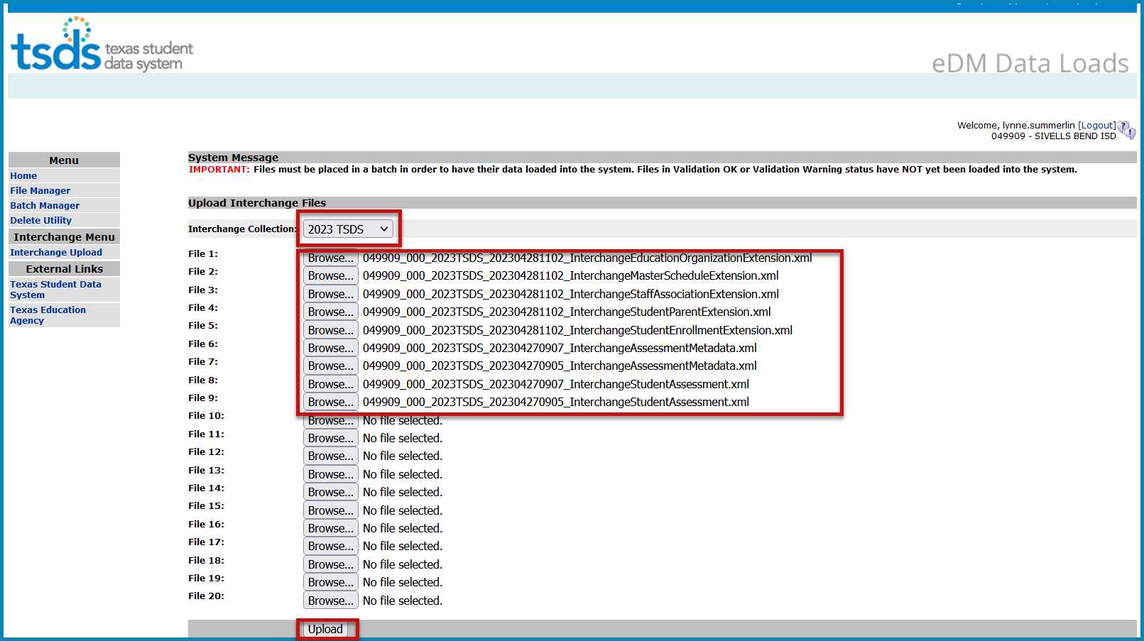
- Click Upload. The files are validated and uploaded to the File Manager.
- Once the files have completely uploaded, the File Manager screen appears.

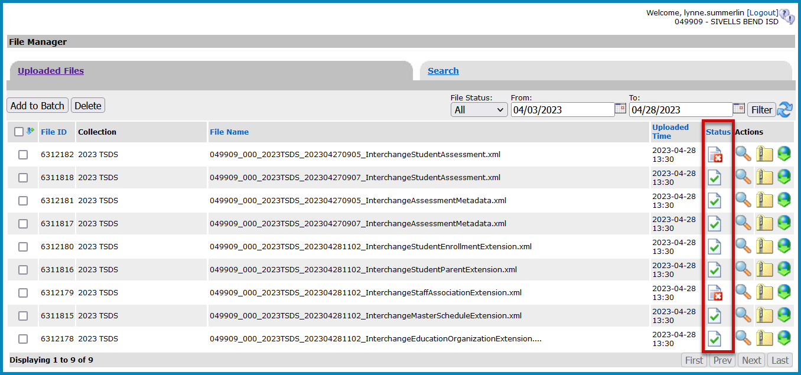

- The files will be processed for errors.
- Any files with errors will have a in the status column. Any failed files will have a in the status column. Errors must be viewed and corrected as needed.

  - File w/errors (red X in center) - To view errors, click on the spyglass, scroll to the bottom of the screen and open the Errors.TAB file(s).
  - Failed File (red X in bottom right corner) – - To view errors, click on the spyglass, scroll to the bottom of the screen and open the Error.zip file or run the file through the Validation Tool to view error results.
- Once all the files have a green checkmark in the status column, select all the files and click Add to Batch.
- If needed, to remove files from the batch, select the appropriate files and click Delete.

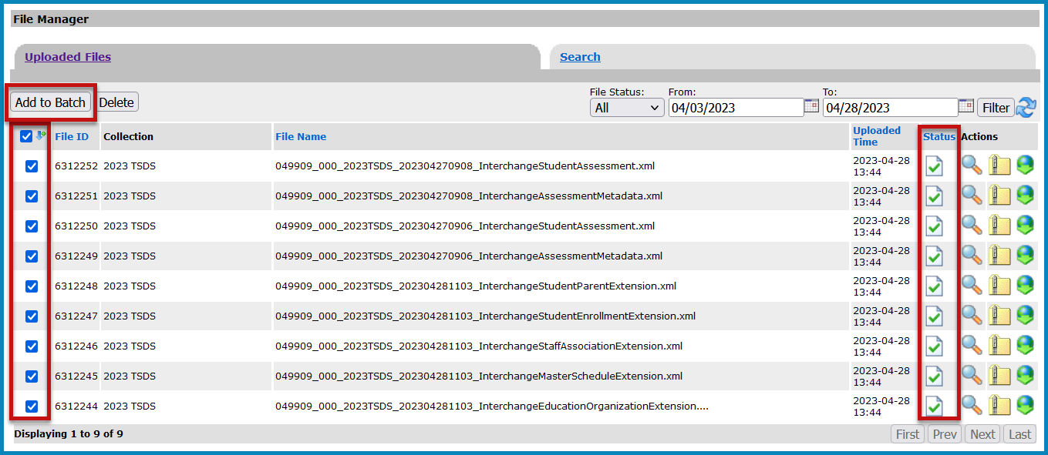
- Select the View Batch button. From this screen the user may add comments regarding the batch, remove files from the batch, or process the batch.

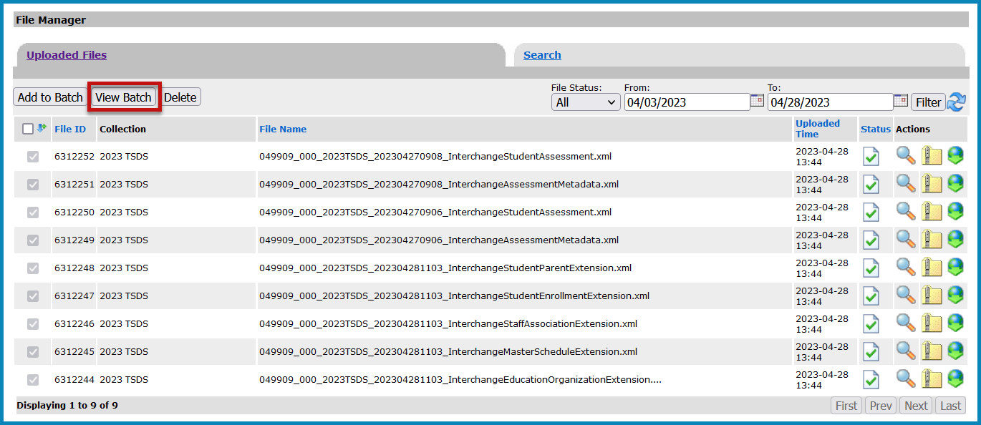

- Name the batch by entering information in the add comments section.
- To process the batch, select the appropriate files and click Process Batch.

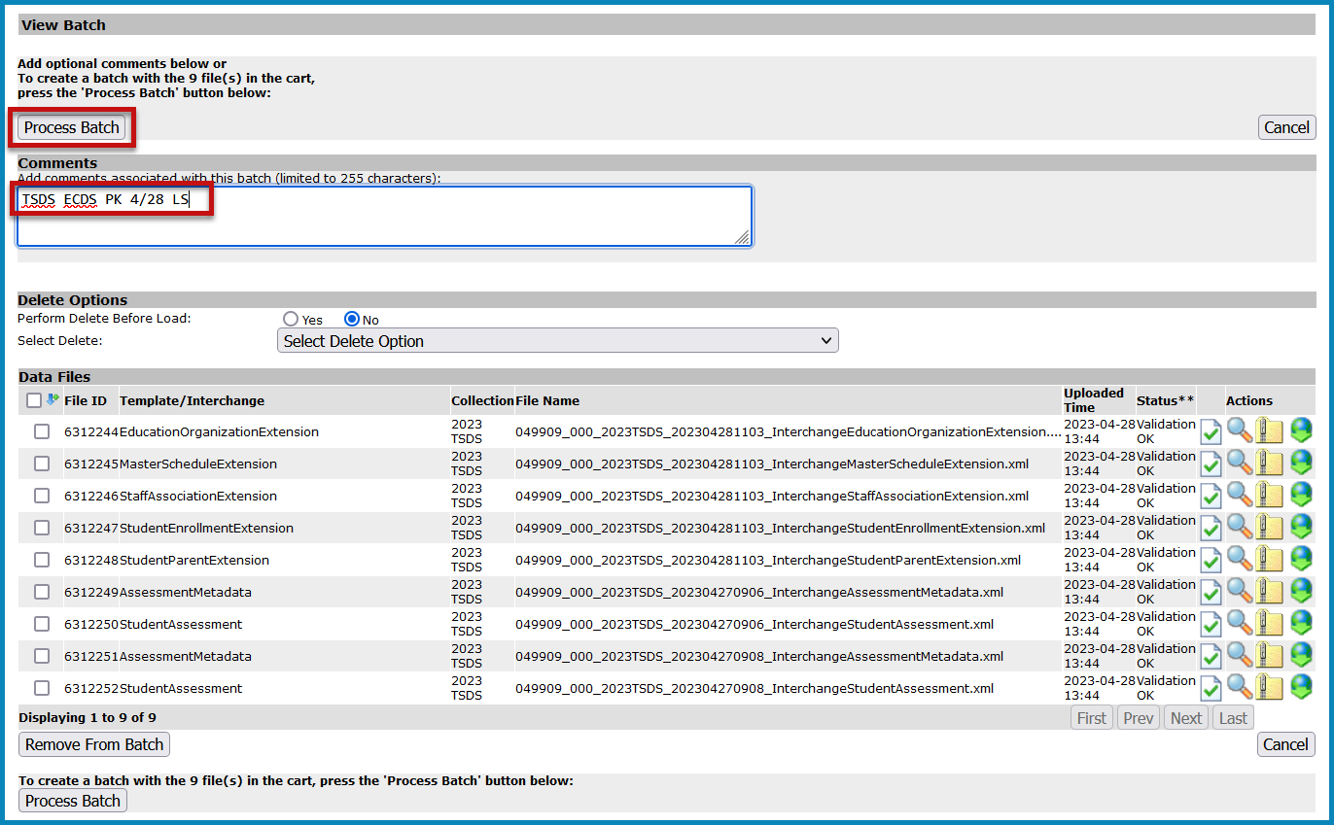
- 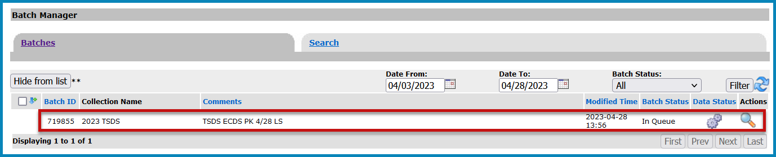The Batch Manager screen appears with a list and status of all batches that have been processed. Batches can have a completed status with errors (red X) or no errors (green checkmark).

- Click the spyglass to open the batch and monitor the progress of the Batch Status.
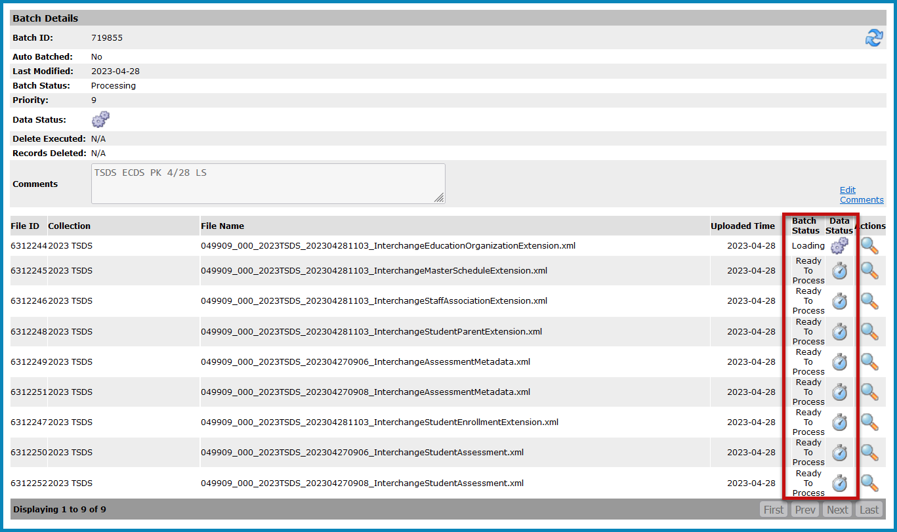
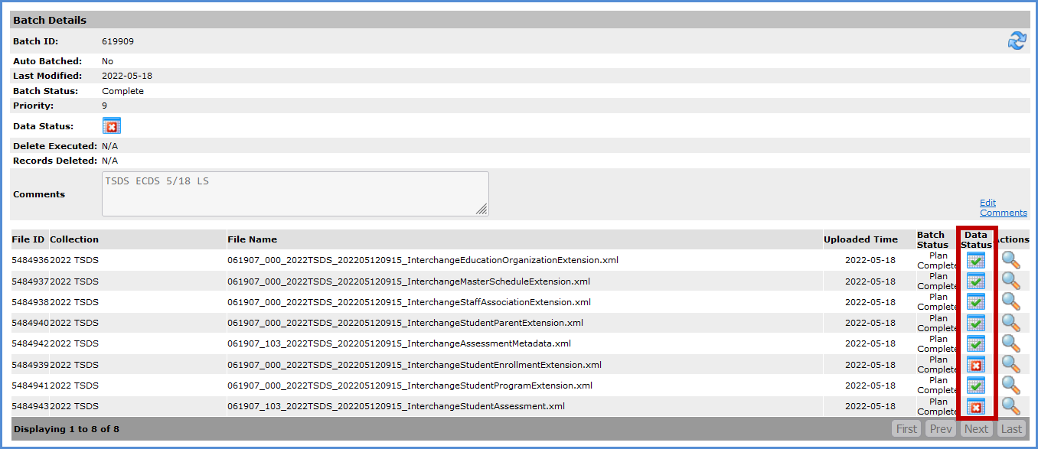
- To view the actual errors, click on the spyglass next to the .TAB file. Click Cancel to return to previous screens.
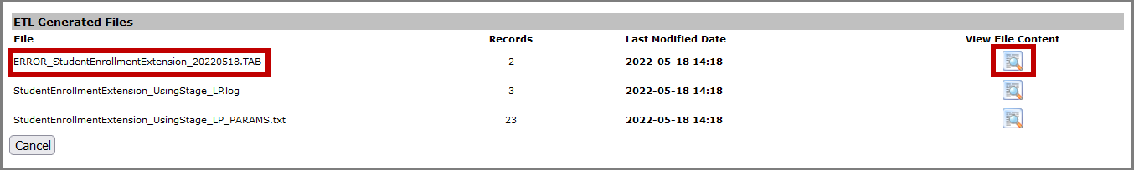

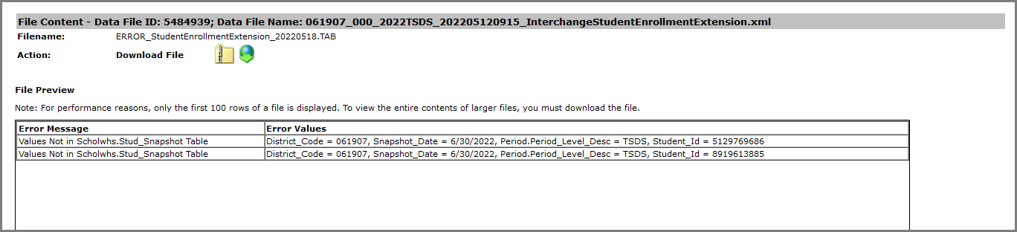

Promote Loaded Data

Once data is loaded and errors have been corrected, users with data promotion privileges can begin the process of promoting data in Promote Loaded Data.

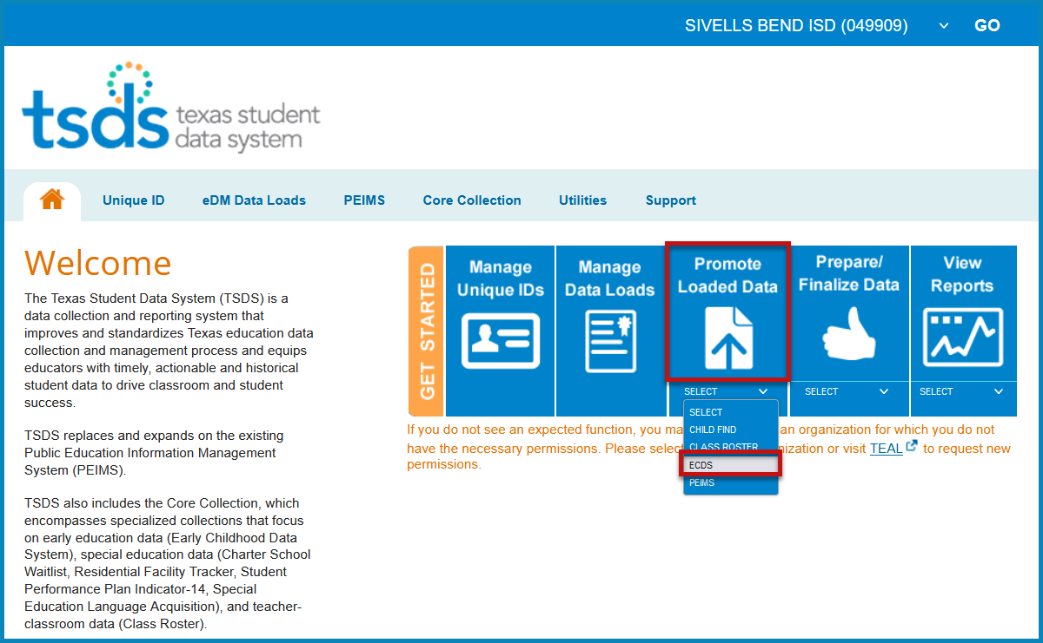

- Click the drop-down menu and select ECDS; click the Promote Loaded Data button.
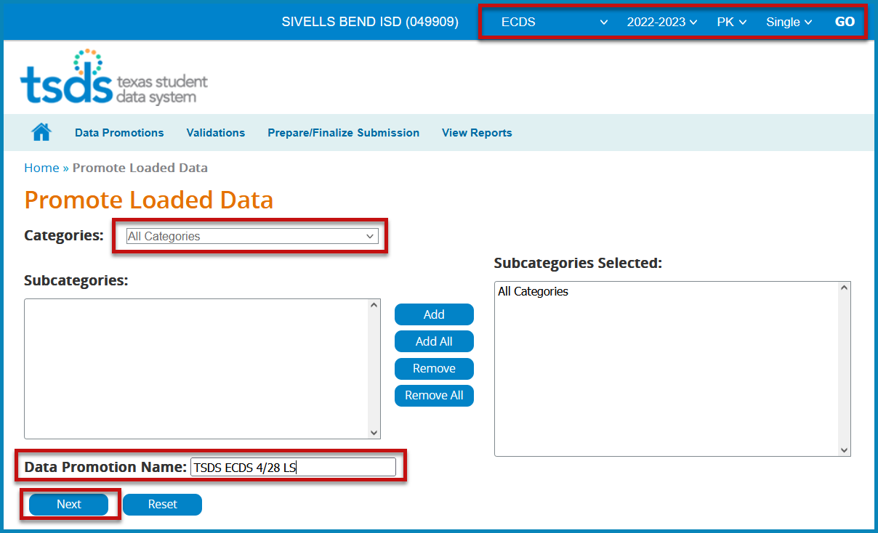

- Select 2022-2023 and PK for the collection. Click GO.
- Under Categories, select All Categories.
- Enter a Data Promotion Name. This name is optional, but it could help identify the data that has been loaded. If the user does not enter a name, the application automatically assigns one.
- Click Next. The Confirm Data Promotion page appears; review the summary of data; click Submit.

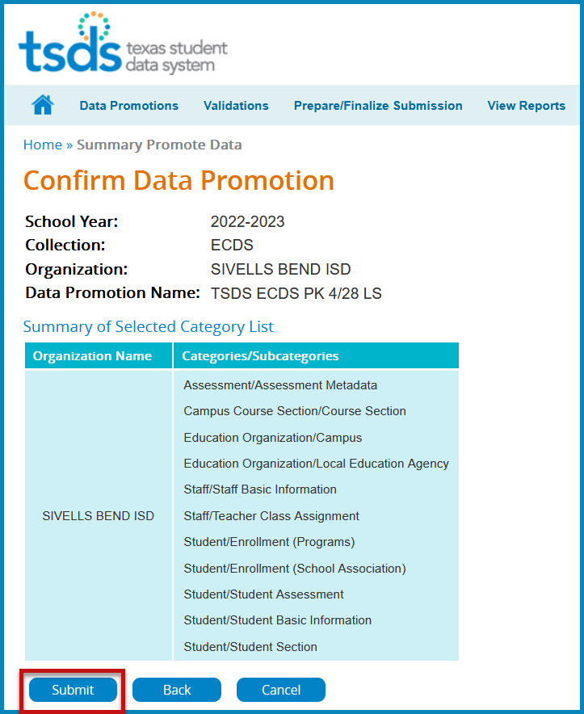

- The Monitor Data Promotions page appears automatically. Otherwise, to open it, select Data Promotions > Monitor Data Promotions from the main menu of the Core Collections home page.

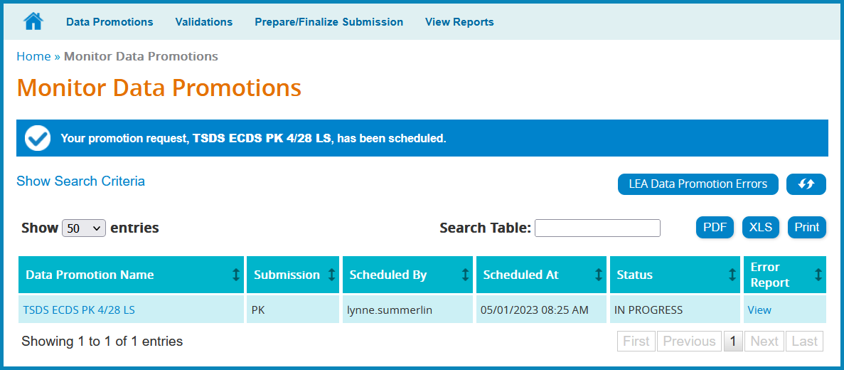

Validate Submission Data

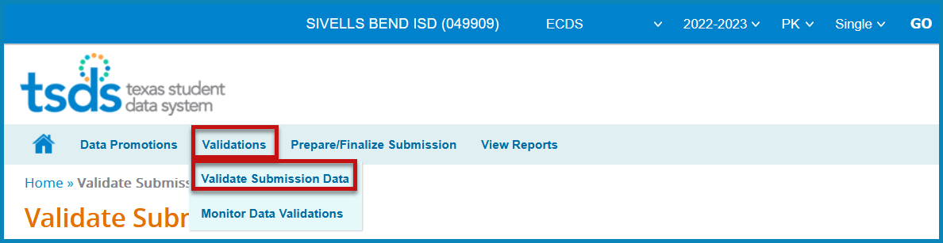

- Select Validations > Validate Submission Data.

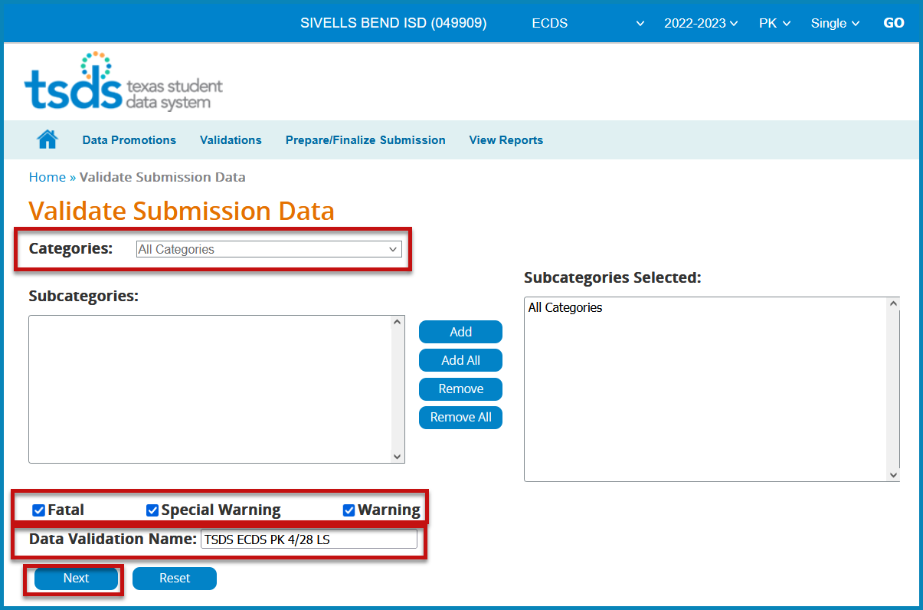

- Select All Categories, Fatal, Special Warning, and Warning.
- Enter a Data Validation Name.
- Click Next. The Confirm Data Validation screen appears; review data and click Submit.

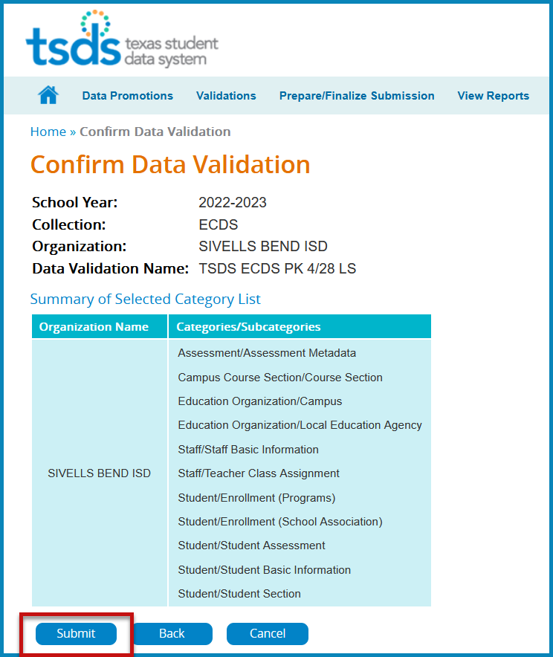

- The Monitor Data Validations screen appears.

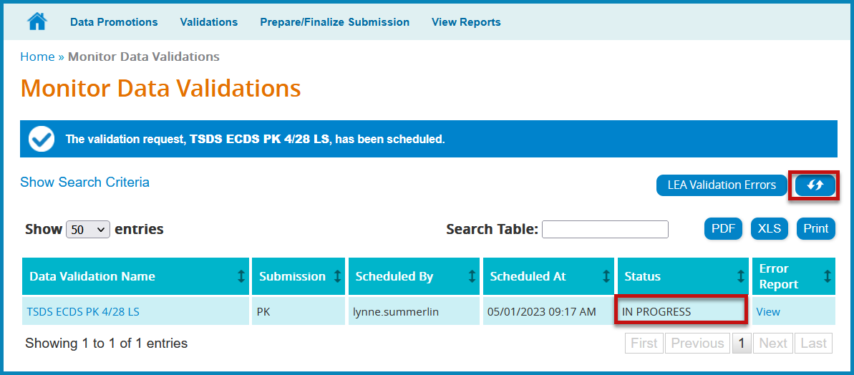

- Click the Refresh button to refresh the screen.

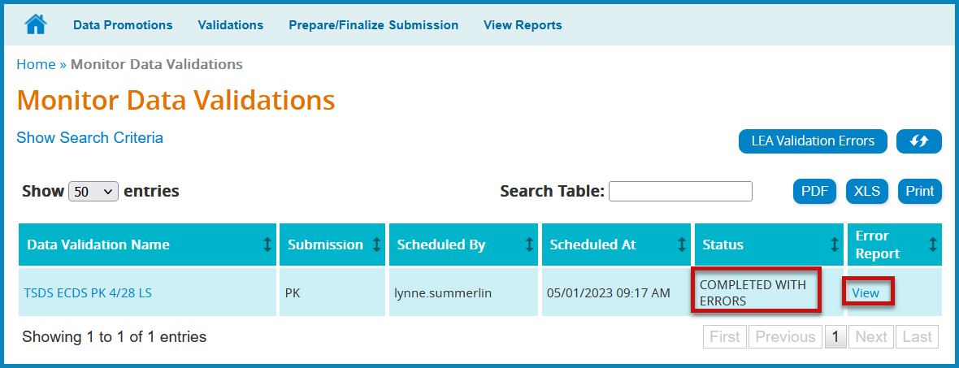
- Click the View button to review Fatals, Warnings, and Special Warnings.

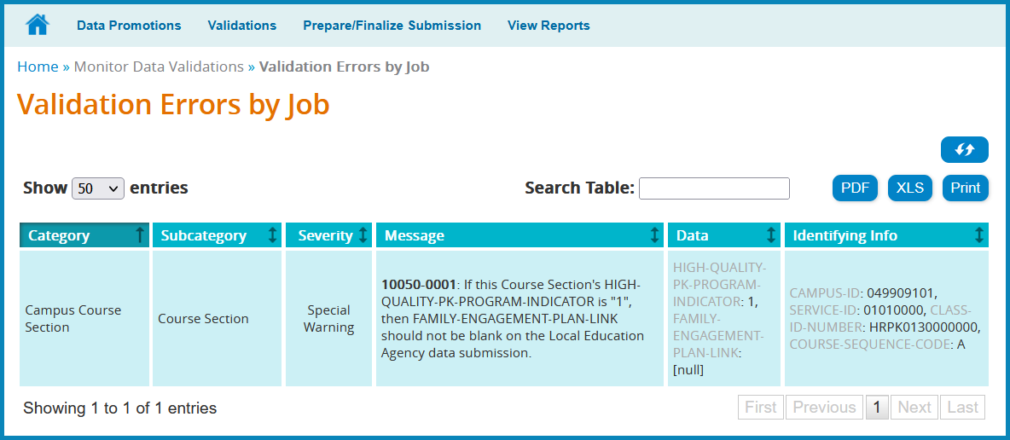

- Make corrections in student software as needed. Create new interchanges, upload, and batch again.
- Make corrections in assessment software as needed. Create corrected interchanges. Load Assessment Data again.
- Promote and validate categories again.
- Repeat steps until data is fatal free and warnings and specials have been verified.

View Reports

Click View Reports. A list of available reports for the selected submission appears on the View Reports screen.

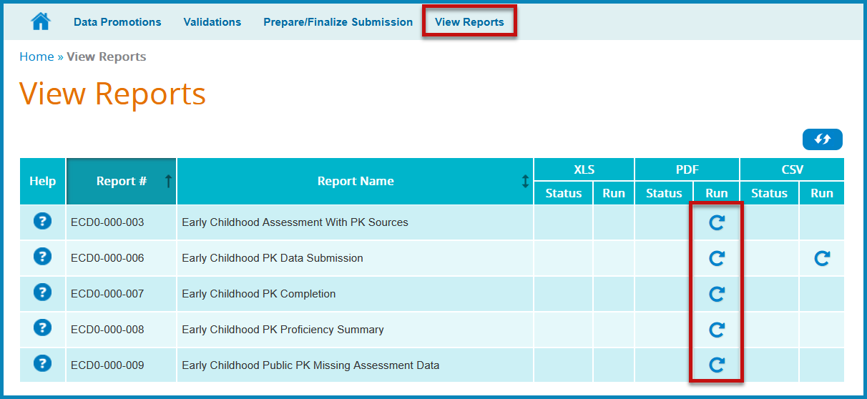

- Click the run icon in the Run column for appropriate report and format. Currently, not all reports are available in both PDF and CSV formats.
- Choose the parameters for the report; click Run to initiate the report. Once the user has initiated the report, the application shows the status as IN PROGRESS.

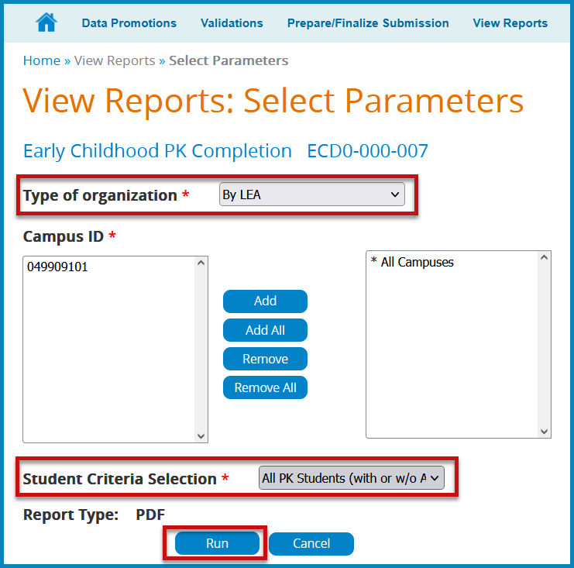

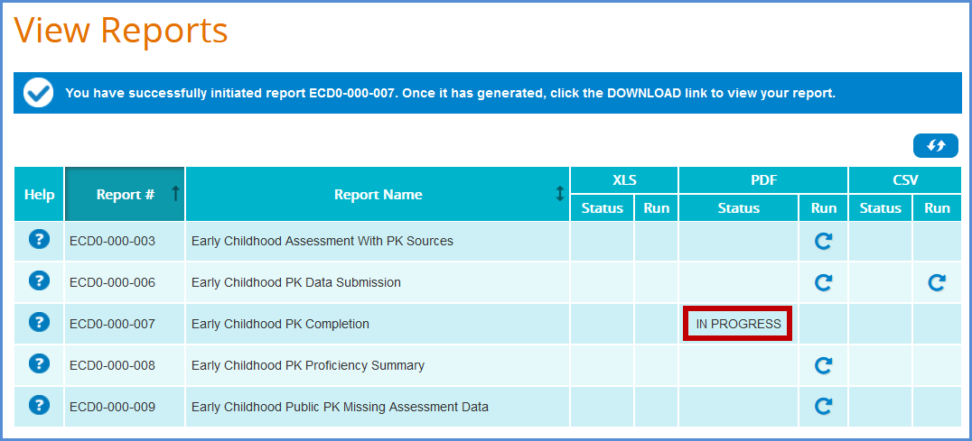
- Click the refresh button to refresh the page until the status changes to DOWNLOAD. Once the DOWNLOAD link appears, the report is ready to open and view.
- Click DOWNLOAD to open the report.

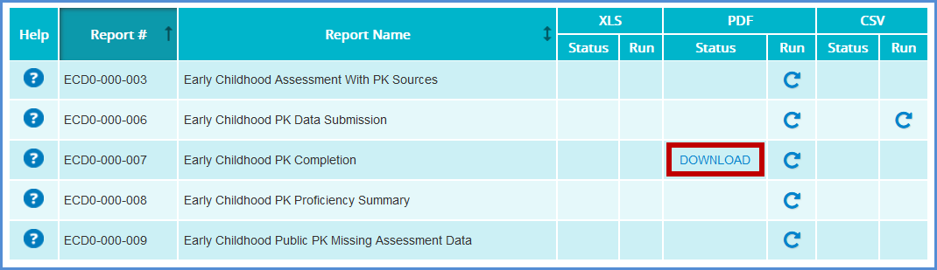

- Have appropriate personnel verify the reports.

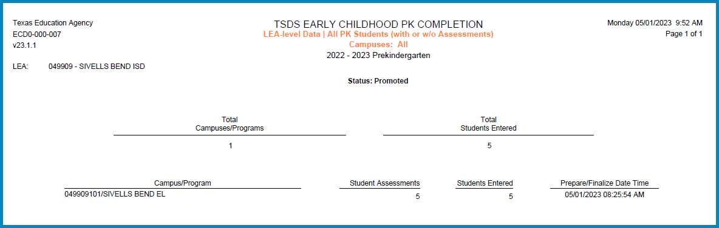

Prepare/Finalize Submission

Before completing the submission, review all reports in the View Reports tab to verify data is accurate.

Note: The submission cannot be completed if it contains fatal errors.

When ready to finalize the submission, confirm that the data status of all subcategories is promoted and validated.

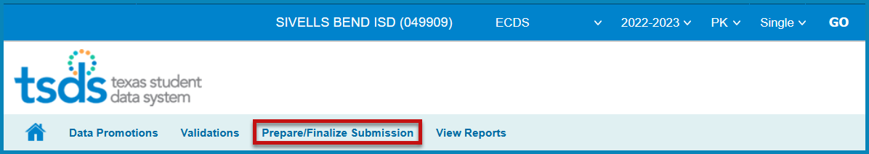

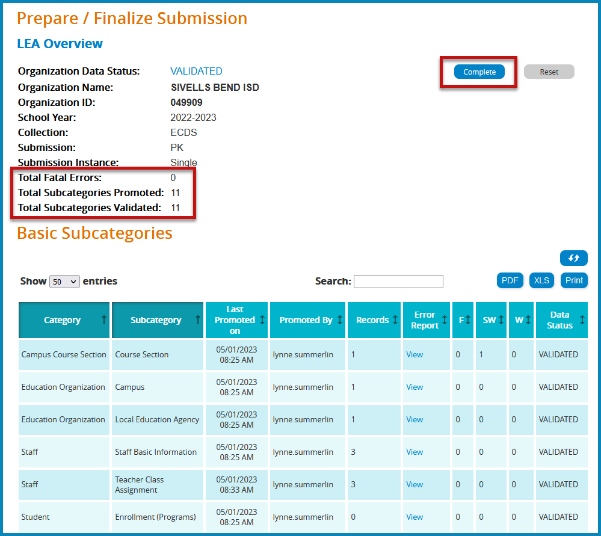

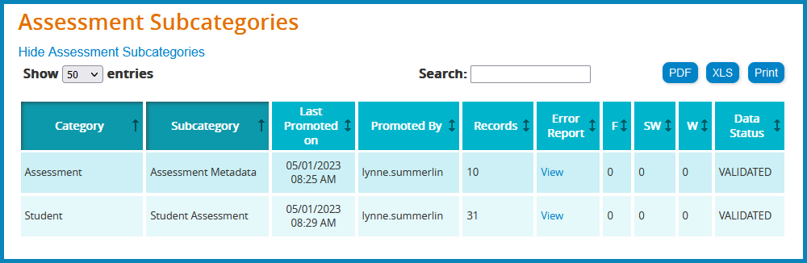

- Click Complete. This prompts another validation of the data. A Completion Process Status message appears showing the progress.
- If there are fatals, the data returns with a status of VALIDATED.
- If there are no fatals, the data returns with a status of COMPLETE.
- A message appears to check the box to acknowledge the data is promoted, validated, reviewed for accuracy and authenticity, and all special warnings and warnings have been reviewed and confirmed.
- Check the box and click CONFIRM.

Reset Submission

If the data needs to be reset to its original state after completion, click the Reset button.

The user can reset the submission anytime up until TEA’s submission due date. Once the submission is marked complete, the data status is set to LEA – DATA COMPLETE and further edits to the data are not available.
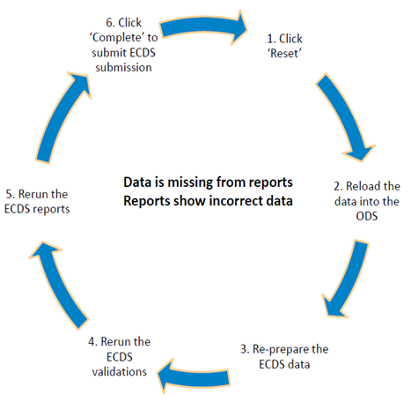

Additional Information

Knowledge Based Articles

TEAL > TSDS > Support > TIMS > Quick Search

Prekindergarten:

- TSDSKB-249 ECDS: General FAQs
- TSDSKB-252 ECDS: KG and PK Assessment Vendor Contact Information
- TSDSKB-254 ECDS: Assessment FAQs
- TSDSKB-450 ECDS: Loading ECDS Data for Public Pre-K
- TSDSKB-451 ECDS: Loading ECDS Data for Public Pre-K (No Assessment)
- TSDSKB-496 ECDS: Collection Requirements
- TSDSKB-508 ECDS: Assessment Specifications
- TSDSKB-553 ECDS: Valid KG and PK Service IDs
- TSDSKB-606 TEAL: TEAL Roles for Core Collections

Delete Utility Example

Use the Delete Utility to “clean-up” student or assessment data.
Verify before deleting TSDS data that no other user is submitting TSDS Core Collections (RF Tracker, Child Find, etc.).

Delete Assessment Data:

- Click on Manage Data Loads.
- From the menu, click Delete Utility.
- Click New Delete Request.
- Click the plus sign next to the 2023 TSDS – Data Collection to view the delete options.
- Click the blue arrow for the appropriate option.

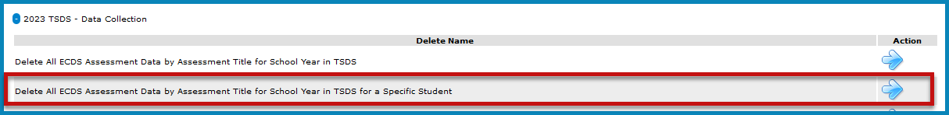

- Type or select the parameters.

  - Select ECDS – PK
  - Select the test to be deleted
  - Enter the Student ID
  - Type comments describing why the data is being deleted.
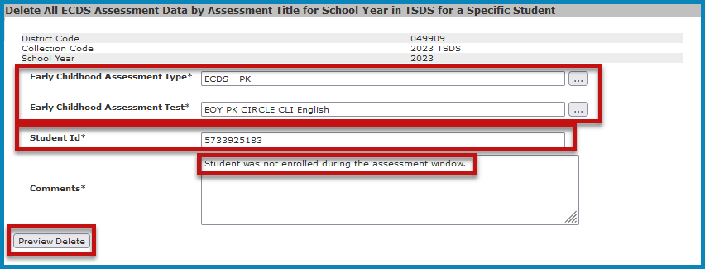

- Click Preview Delete. Review and verify the information to be deleted. Click Cancel to cancel the process.

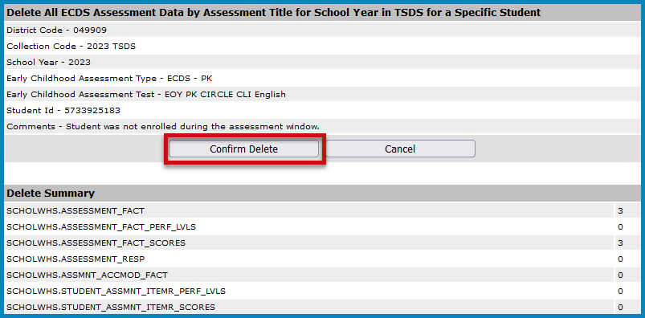
- Click Confirm Delete to perform the deletion.

- Uploading new files, if necessary, can be done after receiving “Success” Status.

ESC Region 11 grants permission to attendees of this session to reproduce and distribute designated resources and materials provided during the presentation.

